Unit 4 Quiz Review Sheet

Angle-Side Relationships in Triangles

**1.** List the angles of∆*PQR* from **2.** List the sides of∆*DEF* from

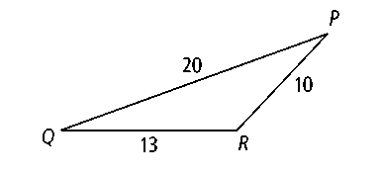smallest to largest. shortest to longest.

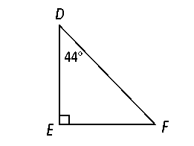

**3. List the angles of ∆*ABC* from smallest to largest. 4. List the sides of ∆*ABC* from shortest to longest.**

*AB* = 3, *BC* = 4, *CA* = 5 *m*∠*A* = 30, *m*∠*B* = 60, *m*∠*C* = 90

Triangle Inequality Theorem

1.

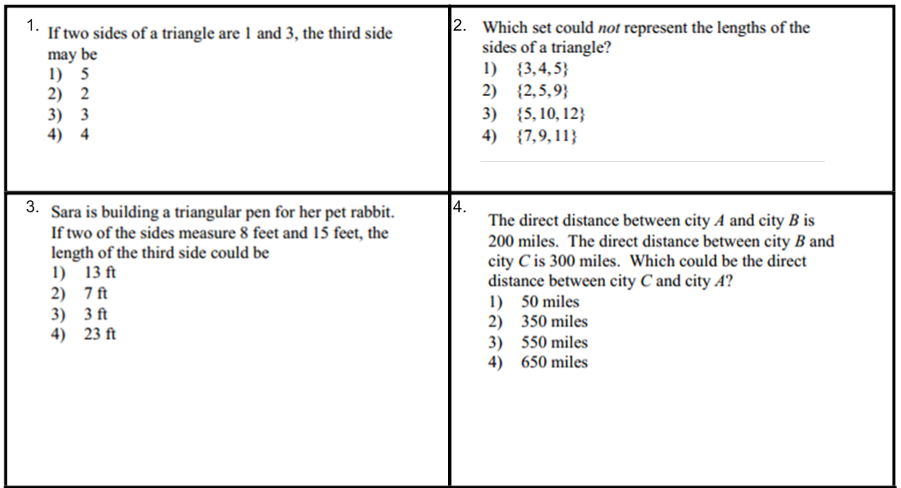

  
2.

3.

Midsegments of a Triangle

1. 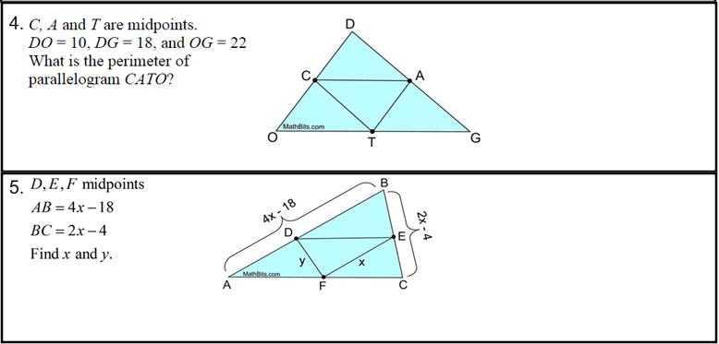



1. Find the value of x.

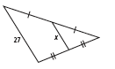

1. Find the value of x.

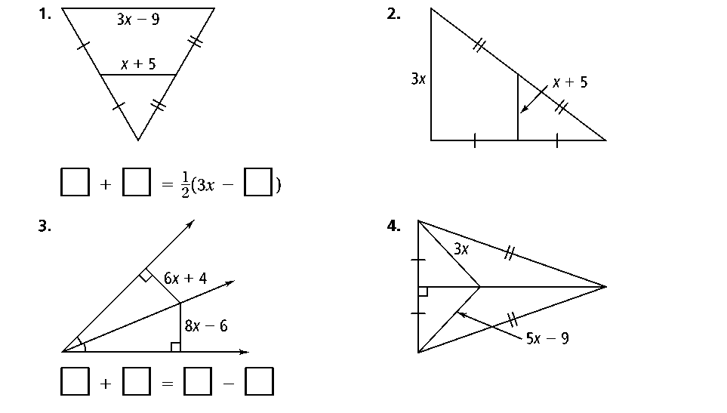

1. Find the value of x.

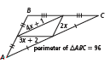

Medians & the Centroid

1. 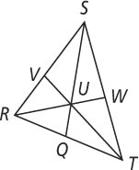**In** ∆***RST, U* is the centroid**If *UQ* = 6, find *US* and *QS .*

If *UT* = 3, find *UV* and *TV .*

If *WT* = 2, find *SW* and *ST.*

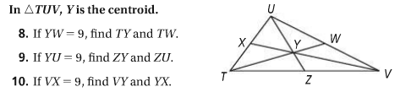

Altitudes & the Orthocenter

*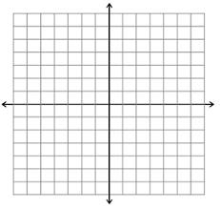***11.** ∆*ABC has vertices A(*–3, 4), *B*(6, 4), and *C*(2, –6). What are the coordinates of the orthocenter of ∆*ABC*?

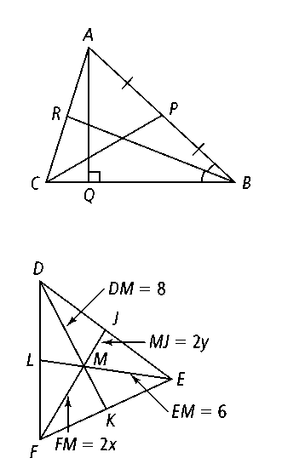**12. Use the figure on the right**

Name an altitude in the figure.

Name a median in the figure.

13. *(4 points)* ∆*ABC* has vertices at *A*(2, 0), *B*(0, 6), and *C*(−5, 0). Find the coordinates of the centroid of ∆*ABC.*

**